Swansea University

Blended Learning Pilot:
VR Pilot

Project Report & Recommendations

Contents
- Summary of VR Activity
- Pilot Projects
- Technical Capabilities/Current Resources
- VR/AR Conference 2018
- Recommendations

Summary of VR Activity

Virtual and Augmented reality

The various colleges at Swansea University have separately experimented with VR and AR (XR) in teaching, however, before the Pilot roll-out, there was no central communication between the independent groups and projects. As such, the VR Learning Technologist’s role was twofold:

- To identify (and where possible support/enhance) existing XR work at Swansea University
- To develop and support new projects in collaboration with academic staff

What follows is a breakdown of the XR activity (both Pilot and non- Pilot) in each participating school or college. To identify existing projects, Pilot staff liaised with the Academic Champions in each college and sent mass emails asking anyone using VR in teaching to get in contact.

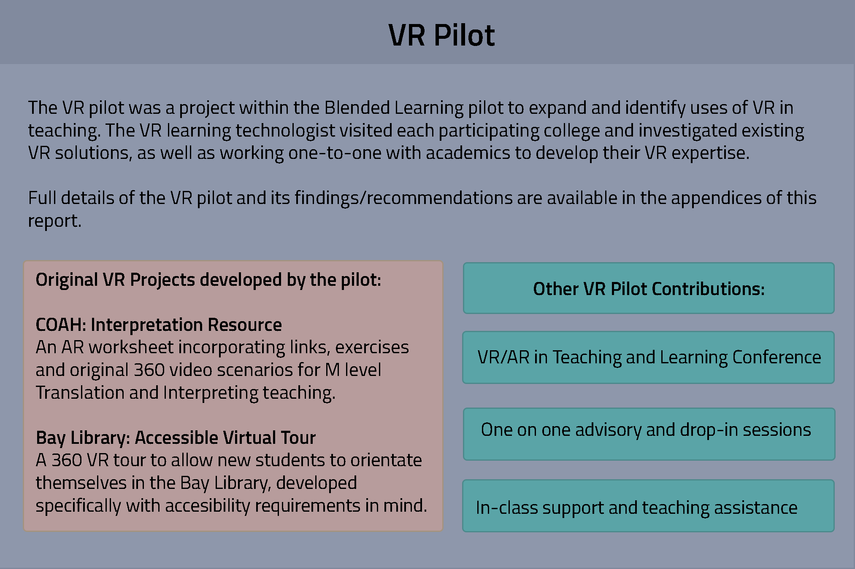

The Swansea University webpage built to showcase individual projects can be found here:
https://www.swansea.ac.uk/vr-in-teaching/

College of Arts and Humanities (COAH)

Work external to the Pilot: Leighton Evans, a Media lecturer in COAH, specialises in VR and will be delivering a module about the history of its use in the 2019/2020 academic year. Due to this specialisation, Leighton recently secured funding to install a VR suite in COAH featuring a wide variety of VR hardware, from room-scale HTC setups to more portable mixed reality and phone-

based Cardboard systems. This new space will increase the accessibility of VR equipment on Singleton Campus.

Pilot work: One of the Pilot development projects is for COAH. Due to the technical nature of VR development, it has not been possible to simply teach/empower academics to produce resources themselves, and the products must be made for them by a Learning Technologist. The resource being produced is for Chiara Ariotti, a modern foreign languages teacher, for use by M level Interpretation students.

After several early ideas and prototypes, the agreed product is an interactive poster/worksheet using AR technology, to act as a ‘hub’ for interpretation exercises. When the students scan the sheet with a capable device, worksheets, exercises and 360 videos will open. When the phone opens the 360 video, the students can slide it into a Cardboard (or similar) headset and view the content in an immersive way. The assessment method for this exercise will be simultaneous interpretation of the video content, either into a voice recorder or to a lecturer physically present.

This project involves producing, writing and filming three 3-6 minute 360 videos, gathering resources and producing a worksheet using Zappar AR functionality.

College of Human and Health Sciences (CHHS)

Work external to the Pilot: Scott Barnett in CHHS oversees the VR currently used in teaching. Pilot staff visited Scott to view their VR solution, a room-scale HTC Vive setup running Organon software. This software allows the user to view every layer of the human body – skin, soft tissue, muscle, bones and organs – in depth and to scale, as well as selecting positions to show these parts from different angles. The functions of each body part are also detailed in the software, which is a powerful anatomical tool.

The benefit of this software is that is allows the students to view the human body in ways previously unimaginable, as access to cadavers for undergraduates is not plentiful. Organon is an opportunity for practical learning, which saves time, money and resources, and has been well received within the college.

CHHS have also invested in a hologram projection system, Prism, but Pilot staff have been unable to visit this, as the college have not been responsive to contact in recent months.

Pilot activity: The VR Learning Technologist visited the CHHS team to demo their teaching software. The team were invited to come to Bay Campus and share knowledge/try the devices available through the Pilot but no further contact was reciprocated.

College of Science

Work external to the Pilot: The College of Science have overall not engaged much with the VR Pilot due to their own AR activities. Computer Science’s HoloLec project uses the HoloLens, but the team did not wish to engage when contacted for the Pilot.

Pilot activity: Elsewhere in the College, Wendy Harris of Biosciences has used VR in teaching. Last academic year, Wendy ran a VR field trip to Oxwich, a significant site on which her students carry out an ecology project. 360 photography was performed on site and made into a virtual tour environment using Unity by Dr Marc Holmes.

On screen panels of text display information within the tour as to the ecological significance, animal habitats and resources of each area shown. This was then used to allow students to revisit the field trip area to assist with their assignments.

A repeat classroom session was performed by the VR Learning Technologist in November 2018 to allow the same cohort to revisit the Oxwich field trip site, using Oculus Go headsets rather than the previously used Cardboards. Results from the surveys they answered, and grades from the project, are not yet available but have been measured and will be shared with the Pilot team.

Hillary Rodham Clinton School of Law

Work external to the Pilot: Ruth Costigan, the academic champion for Law, was contacted to discuss VR teaching solutions and what she would like in her college. Ruth explained that as of AY 2019/20, the entire Law curriculum will change enormously, as the way qualifications are structured will be different.

Pilot activity: Due to the curriculum change, producing a new resource that would soon become obsolete would be pointless. Instead, this time was used to advise Ruth on which existing VR solutions would potentially help without needing to use the curriculum, and it was agreed that using the Bridge Crew app currently used in Engineering as a teambuilding and leadership exercise could be useful. Ruth will contact the VR Learning Technologist if she wishes to implement this in the remaining time on the Pilot, and the role of Pilot staff in this will simply be deployment and in-classroom assistance.

In October a one-on-one training and advisory meeting with Anthony Charles, a Law academic with recruitment responsibilities, was held. In this session he was shown how to use Zappar AR, which he was interested in due to the SALT Conference poster submitted by the BL Pilot team. He plans to use the AR function of Zappar in recruitment materials and will send the Pilot team any materials he produces for information.

School of Management

Work external to the Pilot: Mrs Terry Filer, in the School of Management, worked with Dr Marc Holmes to produce a VR Accountancy App and a Tax app, which allows students to analyse a virtual

environment and appraise it. Mrs Filer submitted a research paper about this app to the VR Conference and has used it widely in teaching, not only in Swansea University but overseas on her visits to partner institutions in China.

Pilot activity: Pilot staff had an advisory meeting with Karima Dyussekeneva, a SoM academic wishing to use AR for data mining. As this is not an application currently in use on the Pilot, and would be better suited to the Hololens, she was directed to the College of Science and their HoloLec Project.

Bay Library

Pilot activity: The Library is not an academic college at Swansea but was allowed to participate due to Medicine’s non-engagement. The VR Learning Technologist woked with Giles Lloyd-Brown to create a 360 tour of the Bay Library as an accessibility aid for new and prospective students. This will combat problems Giles has observed such as students with accessibility needs becoming unsure or overwhelmed due to unfamiliarity with the space, and the larger issue of students being unaware of what the library offers and where things are located.

Accessibility has been at the forefront of both the pros and cons of using VR in teaching and producing an aid specifically with this issue in mind has been very good for the overall project.

College of Engineering

Engineering has been the college most involved with VR at Swansea, with Dr Marc Holmes being the University’s most prominent expert in its use and production. The VR Learning Technologist has consequently spent a large amount of time working in Engineering, as Marc’s VR work in various colleges is a large part of the Pilot itself.

Pilot activity: Due to the availability of Marc, Engineering has the most academics working with VR, some of whom will be discussed in more depth in the attached Case Studies. As an overview, the following projects have been produced in Engineering:

- Dr Andy Tappenden – AR app (Unfinished): A Unity-based app using mathematics to allow students to visualise the angles and forces at play when a beam is bent. The calculations were all completed for this app but due to time constraints the UI and visual front end are not yet complete.

- Dr Patricia Xavier – Grasshoppers 360 Tour: A 360 tour, similar to the one used by Wendy Harris in Biosciences. This was used to allow students to ‘visit’ a construction site both before and after a massive excavation, on which the students wrote their group projects. Feedback from this, whilst all qualitative, was very positive.

- Drs Clare Wood/Ping Yin – Kubity: Architectural software was used with room-scale VR setups to allow Civil Engineering students to visualise plans and building designs. Feedback from this, whilst all qualitative, was very positive.

- Dr Peter Dorrington – Gravity Sketch: Full room-scale VR was used to allow students to load their group design project CAD models into an interactive visualisation and design software, in which they could amend their designs in real time and see them full-scale in person. The students did this in groups of 4-5, with one person in VR and the others observing on a screen, offering ideas and guidance. Feedback from this was encouraging and presented at the VR conference. The VR Learning Technologist supervised students and assisted in these classes, as well as assisting with the collection of qualitative data via interview.

- Dr Laura Mason – Anatomy App: This app was produced by Marc Holmes with Laura Mason for Medical Engineering students. It uses full room-scale VR and requires students to physically assemble a human skeleton in a timed environment. When the skeleton is assembled, students must complete multiple choice questions as to the names of each bone. Laura is one of the only academics to assess the learning gain using both qualitative and quantitative methods as presented at the 2018 AR/VR Conference.

- Dr Jo Hudson – Becoming Victor: As part of a unit on ageing, empathy and perception, Jo Hudson used software which simulated the experience of being an older adult, including slowed movement, the feeling of being ignored by companions, and hearing/vision difficulties. All qualitative results indicate that this was a success and that empathy was indeed generated by use of the app in teaching. Dr Hudson presented on this at the VR conference.

Pilot Projects
Most colleges worked with the VR Pilot by sharing information about their existing projects, borrowing VR hard/software and by consulting the VR Learning Technologist in an advisory or classroom assistance capacity. Two colleges/departments worked with the Pilot in a hands-on way, using the VR Technologist to create bespoke teaching resources to explore the potential of VR as a tool in HE. The following summaries detail those projects. It should also be noted that the projects worked on in Engineering by Dr Marc Holmes before the Pilot Learning Technologists started their posts are also considered as part of the VR Pilot. Due to project timescales, delivery was close to the conclusion of the Pilot and as such we do not have data yet on the reception of each project.

Bay Library Virtual Tour
The VR Learning Technologist worked closely with Library staff to take a serious of 360 images using a Samsung Gear 360 camera, which were then made into a 360 VR tour using Unity. This resource was created in order to help students locate university resources and to make using the Library a more accessible experience for students who need to familiarise themselves with the location before using it.
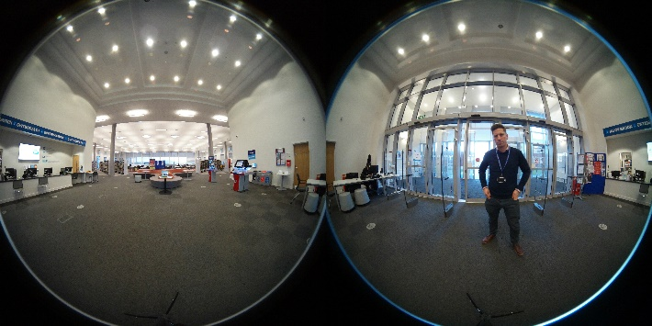
Interpretation Resource
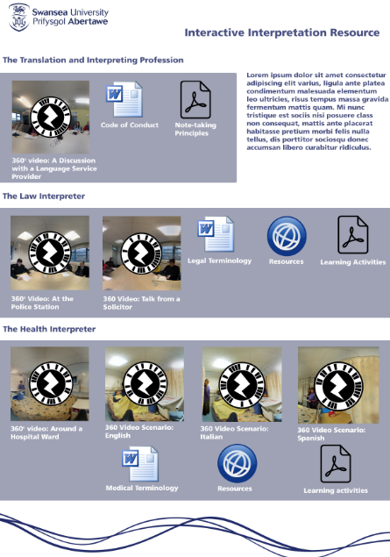
The VR Learning Technologist worked with COAH to produce a worksheet powered by Zappar AR for M Level Translation and Interpreting teaching. This ambitious project included filming multiple 360 video scenarios using staff and students.
These scenarios and the attendant learning resources are housed on a worksheet and open as AR resources when an appropriate mobile device scans them, providing a central hub for the new interpretation content.

Existing Technical Capabilities
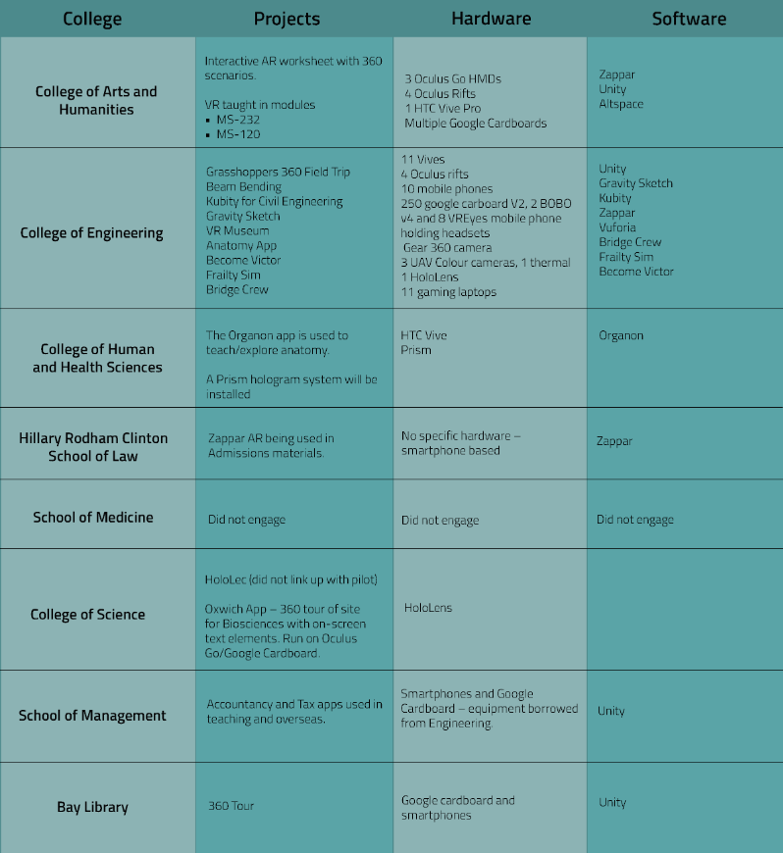

VR Conference
A major contribution from the VR Pilot was the VR/AR Conference 2018 on the theme: Virtual and Augmented Reality to Enhance Teaching and Learning in Higher Education. The VR Learning Technologist took on a large share of the organisation for this international conference, which sought to explore the role VR/AR could play in Higher Education and gather information and examples of its current use in the field.
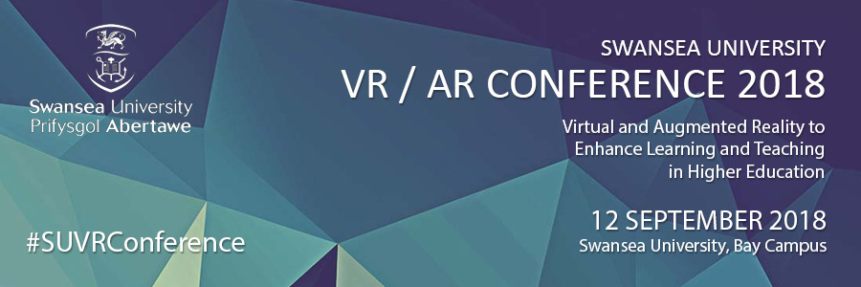
The VR Learning Technologist took on the following roles/tasks:
- Overseeing the creation of marketing collateral
- Logistics such as car parking, space requirements and timetabling
- Down selecting papers and posters for presentation
- Maintaining a robust social media and web presence
- Communication with delegates
- Arranging technical requirements
- Sourcing and securing keynote speakers
The VR/AR Conference was a success and collected experts from around the UK and Europe, increasing the university’s working relationships and knowledge base around XR in Higher Education. A total of – delegates attended and shared knowledge at the event.
Videos, links to individual presenters and tweets from/about the event can be found on Twitter here: https://twitter.com/SU_VRConference/ and under the hashtag #SUVRConference. The work from the conference is also collected online at the following location [link to follow].

Recommendations
Resource Development and Recommendations

The main resource issues in implementing VR in teaching are time and staffing levels. Unlike other Blended Learning methods, for which teaching staff can be trained to produce their own resources fairly easily and inexpensively, the process of creating VR content is very technical and time consuming and requires more training and experience than can reasonably be imparted to all interested staff.

The process of creating VR resources for teaching varies based on which type of VR is being used, and the different media vary in complexity:

- Room-scale VR: Full room-scale simulations, such as the Anatomy App or the Virtual Museum, are by far the most complex to produce. Using Unity, the developer must essentially produce a video game, as well as creating the 3D assets used in the app. This can then be run on an HTC Vive, Oculus Rift or Windows Mixed Reality headset. Not only is this by far the most labour intensive, it requires the most expensive hardware to run, making it more difficult to deploy for large classes.

At present, Dr Holmes in Engineering and his team are the only people known to the Pilot capable of this, and development is not a fast process. Sadly, while very effective in teaching due to the levels of immersion and ease of visualisation, for most colleges, producing room-scale VR apps would not be possible without at least a designated Learning Technologist or Unity Developer per college. In addition to the high cost per unit of the VR headsets, computers capable of running VR are expensive, and at the very least a high spec gaming laptop would be necessary.

If colleges are willing to invest in room-scale VR, one headset per six students in a classroom is the minimum requirement. Any fewer than this and group work will become difficult, and
observers run the risk of not getting their ‘turn’ and disengaging. This obviously comes at a high price and may not be within the scope of many colleges at present.

- 360 VR: VR experiences using 360 video and photography are the easiest and cheapest to produce and run. They are particularly effective when used to allow students to ‘visit’ locations and get a sense of place and scale, and qualitative research from academics such as Dr Patricia Xavier suggests that students appreciate and benefit from using these methods.

It is also possible to train somebody with good general IT skills to assemble one of these projects in Unity, particularly using the custom UI created by Ted Thomas in Engineering. The photography for these projects can be performed by anyone. Access to photoshop or GIMP is required to edit the images, but while the process is time consuming, it is not overly difficult to master.

These projects are generally run on Cardboard headsets using a mobile phone, which can be a problem in terms of accessibility for lower-income students and those who do not own smartphones – anyone using this technology needs to have a stock of phones to provide for these students. Alternatively, an Oculus Go can be used, although this does increase the running cost financially. Engineering currently have 30+ Oculus Go sets, and Leighton Evans
has multiple sets in his VR lab in COAH, so at least two colleges are capable of medium-scale deployment.

Should colleges choose to develop lower-spec solutions such as 360 projects, they would need to purchase Samsung Gear 360 cameras or equivalent, and laptops capable of running Unity smoothly. A bulk order of Cardboard headsets equates to around £5 per set, but running with these is not as high quality as with the Oculus Go, which retails at £200-£250 – the decision on which to purchase will probably come down to cohort size, but it is worth remembering that sometimes purchasing smartphones can make the Cardboard the more expensive option. As with the room-scale solution, each college would need at least one full-time member of staff dedicated to developing this content.

Programme Level Planning

As with the findings of the wider Blended Learning Pilot, the VR Pilot has shown that introducing XR content individually or on a module-by-module basis can lead to issues of inconsistency across programmes, in which students perceive a difference in quality or learning gain based on which resources are available or offered to them. XR is not the appropriate solution for every subject and should only be used as an educational tool when it can add value.

XR should be implemented in teaching at programme level to ensure it is used in a way which gives students even access to the resource, and that it is used in the most appropriate contexts per programme. The VR Pilot fully supports the recommendations of the wider Blended Learning Pilot report.

